**Teacher Notes for**

**How Animals Adapt to Their Environments – Examples and Evolution[1]**

In this activity, students analyze examples of adaptations, including camouflage, mimicry of an inedible object, and phenotypic plasticity. Phenotypic plasticity means that a single genotype can develop different phenotypes in different environments. Phenotypic plasticity allows an individual organism to adapt to different environments during its lifetime. Natural selection for an adaptation allows a population of organisms to adapt to different environments over time.

As background, students should have a basic understanding of natural selection. For this purpose, I recommend:

* the hands-on activity, "Evolution by Natural Selection" (<http://serendipstudio.org/sci_edu/waldron/#evolution>) or
* the analysis and discussion activity, “What is natural selection?” (<https://serendipstudio.org/exchange/bioactivities/NaturalSelectionIntro>).

**Learning Goals**

In accord with the Next Generation Science Standards[2]:

* Students will meet the Performance Expectation HS-LS4-4: "Construct an explanation based on evidence for how natural selection leads to adaptation of populations".
* Students will learn the Disciplinary Core Idea, LS4.C Adaptation: “Natural selection leads to adaptation, that is to a population dominated by organisms that are anatomically, behaviorally and physiologically well suited to survive and reproduce in a specific environment. That is, the differential survival and reproduction of organisms in a population that have an advantageous heritable trait leads to increases in the proportion of individuals in future generations that have the trait and to a decrease in the proportion of individuals that do not.” “Adaptation also means that the distribution of traits in a population can change when conditions change.”
* Students will engage in Scientific Practices, including “Constructing Explanations: Apply scientific ideas, principles, and/or evidence to provide an explanation of phenomena…”
* This activity can be used to foster student understanding of the Crosscutting Concept, “Stability and Change: Much of science deals with constructing explanations of how things change and how they remain stable.”

Additional Content Learning Goals

* In everyday usage, people refer to an organism adapting to its environment within its lifetime. Biologists call this phenotypic plasticity.
* Biologists use the term adaptation to refer to a heritable characteristic that increases survival and/or reproduction.[3] By natural selection, an adaptation becomes common in a population.
* Phenotypic plasticity can be an adaptation that optimizes fitness in a variable environment.

This activity counteracts several common misconceptions about evolution[4]:

* The fittest organisms in a population are those that are strongest or fastest.
* Evolution only occurs very slowly.
* Evolution is not science because it is not observable or testable.

**Instructional Suggestions and Background Information**

To maximize student participation and learning, I suggest that you have your students work in pairs to complete each group of related questions and then have a class discussion after each group of questions. In each discussion, you can probe student thinking and help them develop a sound understanding of the concepts and information covered before moving on to the next group of related questions.

If your students are learning online, I recommend that they use the Google Doc version of the Student Handout available at <https://serendipstudio.org/exchange/bioactivities/evoadapt>. To answer question 4, students can either print the relevant page, draw on it, and send a picture to you, or students will need to know how to modify a drawing online. To answer online, they can double-click on the relevant drawing in the Google Doc to open a drawing window. Then, they can use the editing tools to answer the questions.

You may want to revise the Word document or Google Doc to prepare a version of the Student Handout that will be more suitable for your students. If you use the Word document, please check the format by viewing the PDF.

A key is available upon request to Ingrid Waldron ([iwaldron@upenn.edu](mailto:iwaldron@upenn.edu)). The following paragraphs provide additional instructional suggestions and background information – some for inclusion in your class discussions and some to provide you with relevant background that may be useful for your understanding and/or for responding to student questions.

The figures from the Student Handout are available as a PowerPoint (available at <https://serendipstudio.org/exchange/bioactivities/evoadapt>) to show color camouflage and for use in class discussion.

Cephalopods

The cephalopods considered in this activity (octopuses, squid and cuttlefish) are mollusks that don’t have shells. Cephalopod camouflage shows phenotypic plasticity in color, pattern and texture. This phenotypic plasticity appears to play an important role in helping these soft-bodied animals to avoid predation and probably also contributes to their success in hunting prey.

The first recommended video, “Octopus Camouflage” (<https://www.youtube.com/watch?v=eS-USrwuUfA>) is 4.5 minutes long and includes octopus, cuttlefish and squid. The size of each individual chromatophore is controlled by radial muscles, which contract to expand the chromatophore (<https://www.nature.com/scitable/topicpage/cephalopod-camouflage-cells-and-organs-of-the-144048968/>). After this video was made, research with a species of cuttlefish found that there are many more patterns than the three postulated by Dr. Hanlon (<https://www.nature.com/articles/s41586-023-06259-2>). The second recommended video, “Cephalopod Camouflage” (<https://tinyurl.com/cephcamoflage>) is 3.5 minutes long and shows some of the same video, but with some additional information.

Question 1 introduces crucial vocabulary for this activity. Note that phenotypic plasticity is often called adapting, but biologists generally prefer the term phenotypic plasticity, which is less likely to be confused with adaptation in the evolutionary sense.

Peppered Moth Caterpillars and Adults

*Biston betularia* is the scientific name for peppered moths. If your students are not familiar with the lifecycle of moths, you may want to show them this figure (which is also available as slide 3 in the PowerPoint (available at <https://serendipstudio.org/exchange/bioactivities/evoadapt>)).

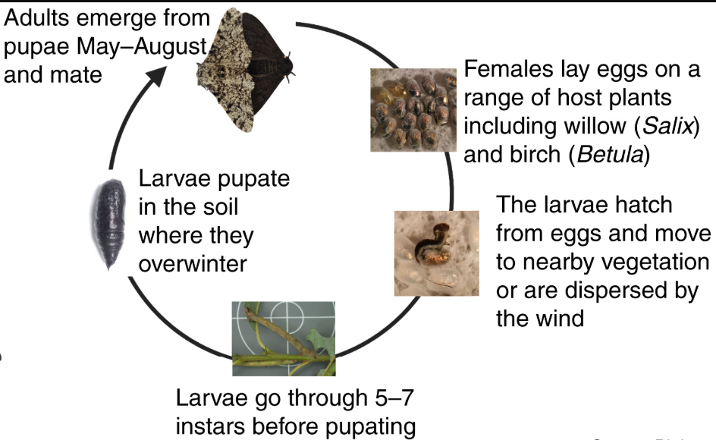

Larvae = caterpillars; each instar before the last ends with a molt to the next larger instar;

the largest instar pupates to produce an adult peppered moth.

(<https://www.cell.com/cms/10.1016/j.cub.2022.03.071/asset/33fb0a23-5601-4646-8a22-524d058ce999/main.assets/gr1_lrg.jpg>)

Peppered moth caterpillars can only change colors when they molt. They use vision in their skin to match the color of the branches of the trees that they are on.

Near the bottom of page 2 of the Student Handout, the figure on the left shows a peppered moth caterpillar looking like a twig. When caterpillars rested at an angle that mimicked the angle of a branch, birds were more likely to attack a branch before a caterpillar. Also, attacks on caterpillars that were mimicking a twig came after a longer delay than when caterpillars were resting flat on the branch. (<https://www.nature.com/articles/s41598-020-78686-4#Abs1>)

If you have trouble finding the speckled form of the adult peppered moth in the figure on the left on page 3 of the Student Handout, it may help you to know that it is near the lower left-hand corner, with its head upward.[5] If your students do not know what lichen is, you may want to explain that lichen is a mutualistic symbiosis of fungi with photosynthetic cyanobacteria or algae. The fungi benefit from the carbohydrates produced by the cyanobacteria or algae. The cyanobacteria or algae benefit from protection from desiccation and strong sunlight provided by the fungi, as well as the minerals and anchoring to the substrate typically provided by the fungi. (<https://en.wikipedia.org/wiki/Lichen>)

Discussion of student answers to question 5 should include the important generalization that environment influences whether a characteristic is an adaptation.

The graph on page 4 of the Student Handout provides representative data for the trends in the proportion of peppered moths that were dark in an industrial region of England. In the graph, the total width of the shaded line represents 99% confidence intervals, and the width of the darkest part of the line indicates 50% confidence intervals. This graph illustrates the following important points.

* Different characteristics are adaptations in different environments.
* Evolutionary changes can occur within several decades when the environment changes.
* Environmental changes that are subsequently reversed may result in evolutionary changes that are similarly reversed.

|  |  |
| --- | --- |
| It is of interest that, during the second half of the 20th century, similar trends were observed in industrial regions in England and the US. After ~1960, air pollution decreased and the percent of peppered moths that were dark decreased.  In non-industrial rural regions, air pollution remained low throughout the 20th century, and natural selection kept the percent of dark peppered moths near zero. |  |

In addition to birds, bats are also important predators on adult male peppered moths. (The females fly very little so they are less subject to predation by bats.) Unlike birds, bats are not visual predators and are equally likely to eat speckled or dark peppered moths. As discussed above, the caterpillars of the peppered moth are also subject to predation by birds, and these caterpillars have a different type of camouflage that is independent of the adult dark vs. speckled forms. The available evidence indicates that bat predation on adult moths, bird predation on caterpillars, and other causes of mortality appear to be generally equal for both adult color forms. These additional causes of mortality are one reason why natural selection for dark or speckled forms of the peppered moth resulted in relatively gradual changes in the proportion of adult peppered moths with the dark color form.

Before question 8, you may want to reinforce student understanding of natural selection of the color forms of adult peppered moths by showing your students the 4-minute video, “Natural Selection Song: The Ballad of the Peppered Moth” (<https://www.youtube.com/watch?v=uV5-FKT16r0>). I suggest that you stop this video at 3 minutes and 31 seconds, before the part about Kettlewell and Majerus, which is not relevant for most high school students.

There has been some controversy concerning the cause of the trends in the speckled vs. dark forms of the peppered moth (see "Industrial Melanism in the Peppered Moth, *Biston betularia*: An Excellent Teaching Example of Darwinian Evolution in Action", *Evo Edu Outreach* (2009) 2:63-74). Aspects of this controversy have been beneficial since they have identified flaws in some of the earlier research and stimulated improved research which has provided strong evidence for the importance of natural selection due to predation by birds on adult peppered moths (see e. g. <http://rsbl.royalsocietypublishing.org/content/roybiolett/8/4/609.full.pdf>).

The bottom of page 4 clarifies the important distinction between:

* phenotypic plasticity (which allows an individual organism to adapt to different environments during its lifetime) and
* natural selection for an adaptation (which allows a population to adapt to different environments).

In contrast to the everyday meaning of individuals adapting to their environment, evolutionary biologists define adaptation as a heritable characteristic that helps an organism to survive and reproduce. This important distinction is the reason why biologists prefer “phenotypic plasticity” to “adapting” to describe the ability of an organism to adapt to its environment during its lifetime.

Daphnia (the Water Flea)

This section is a little more challenging than the previous sections, and the previous sections can stand alone. Therefore, you may want to omit this section if your students are liable to be confused by this demonstration that natural selection can increase phenotypic plasticity.

A very common invertebrate predator can only fit smaller Daphnia in its prey-capturing structure (<https://www.ruhr-uni-bochum.de/ecoevo/Bilder/pubs/tollrianpu/chaoboruscatchingbasket.pdf>). Thus, larger Daphnia avoid predation by this invertebrate. Fish that prey on Daphnia are visual predators, and they are more likely to detect and eat larger prey (see references in <https://esajournals.onlinelibrary.wiley.com/doi/pdf/10.1002/ecs2.3192>). Thus, one way of escaping fish predation would be to be smaller. In this context, one might predict phenotypic plasticity in size related to the presence or absence of fish smell in the water. (<https://www.mdpi.com/1424-2818/12/4/147#:~:text=Inducible%20defences%20in%20prey%20species,by%20predatory%20invertebrates%20and%20fish>)

Scientists tested this prediction by comparing the size of *Daphnia magna* that developed in water with fish smell vs. in water without fish smell. To obtain genetically identical Daphnia that developed in these two different conditions, the scientists took advantage of the fact that Daphnia frequently reproduce asexually to produce clones of genetically identical individuals. For each sample, tests for phenotypic plasticity compared 12 pairs of Daphnia that had been raised in water with vs. without fish smell; each Daphnia pair was genetically identical because they were derived from the same clone.

The Daphnia for this experiment were from a pond that had no fish during the early years (sampled 1970-1972). Then, the pond was stocked with many fish in 1975. This began a period of high fish density (sampled 1976-1979). Significant increases in phenotypic plasticity for several characteristics were observed for the sample taken when the pond was stocked with many fish. (<https://onlinelibrary.wiley.com/doi/10.1111/ele.12551>)[6]

**Sources for Figures in the Student Handout**

* Figure of octopus emerging from camouflage – from <https://www.nature.com/scitable/topicpage/cephalopod-camouflage-cells-and-organs-of-the-144048968/>
* Figure of peppered moth caterpillars on brown birch and green willow branches – from <https://journals.plos.org/plosone/article?id=10.1371/journal.pone.0003142>
* Figure of peppered moth caterpillar mimicking a twig – modified from <https://www.nature.com/articles/s41598-020-78686-4/figures/1>
* Figure of adult peppered moths on two different backgrounds – from <http://www.ucl.ac.uk/~ucbhdjm/courses/b242/OneGene/peppered.html> and <https://catherinephamevolution.weebly.com/the-british-peppered-moth.html>
* Graph of trends in percent of peppered moths that were dark – modified from <file:///C:/Users/Ingrid/Downloads/nature17951%20(1).pdf>
* Photo of a Daphnia – from <https://www.carolina.com/images/product/small/142314_w.jpg>

**Follow-up Activities**

"Resources for Teaching and Learning about Evolution" (<http://serendipstudio.org/exchange/bioactivities/evolrec>).

These Teacher Notes provide (1) suggestions for teaching evolution to students with religious concerns, (2) a review of major concepts and common misconceptions concerning natural selection, with recommended learning activities, (3) a review of major concepts and common misconceptions about species, descent with modification, and the evidence for evolution, with recommended learning activities, and (4) recommended general resources for teaching about evolution.

1. By Dr. Ingrid Waldron, Department of Biology, University of Pennsylvania, © 2025. These Teacher Notes and the related Student Handout are available at <https://serendipstudio.org/exchange/bioactivities/evoadapt>.
2. Quotations are from <https://www.nextgenscience.org/> and <http://www.nextgenscience.org/sites/default/files/HS%20LS%20topics%20combined%206.13.13.pdf>
3. The Student Handout gives an incomplete definition of an adaptation on page 1 and a complete definition on page 3.
4. These misconceptions are excerpted from *Misconceptions about Evolution*, available at <http://evolution.berkeley.edu/evolibrary/misconceptions_teacherfaq.php>
5. You may want to substitute the more in-depth activity, "Natural Selection and the Peppered Moth" (<https://serendipstudio.org/exchange/bioactivities/NaturalSelectionMoth>), for pages 3-4 on adult peppered moths in the current activity.
6. This paper also reported data for a later time period of reduced fish density (1988-1990, approximately 10 years after fish stocking ended). Comparison of Daphnia from the period of high fish density with Daphnia from the later period of lower fish density also showed expected evolutionary changes in phenotypic plasticity.